1. Problem Description:

Develop a Python program that safely calculates the square root of a number provided by the user. Handle exceptions for negative inputs and non-numeric inputs.

Input Format:

User inputs a number.

Output Format:

Print the square root of the number or an error message if an exception occurs.

**For example:**

| **Input** | **Result** |
| --- | --- |
| 16 | The square root of 16.0 is 4.00 |
| -4 | Error: Cannot calculate the square root of a negative number. |
| rec | Error: could not convert string to float |

Program:

import math

try:

n = input()

number = float(n)

if number < 0:

print("Error: Cannot calculate the square root of a negative number.")

else:

sqrt_result = math.sqrt(number)

print(f"The square root of {number} is {sqrt_result:.2f}")

except ValueError:

print("Error: could not convert string to float")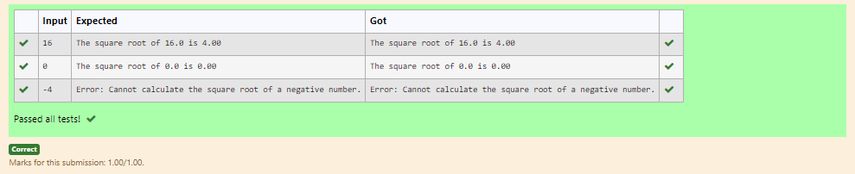

2. Problem Description:

Write a Python script that asks the user to enter a number within a specified range (e.g., 1 to 100). Handle exceptions for invalid inputs and out-of-range numbers.

Input Format:

User inputs a number.

Output Format:

Confirm the input or print an error message if it's invalid or out of range.

**For example:**

| **Input** | **Result** |
| --- | --- |
| 1 | Valid input. |
| 101 | Error: Number out of allowed range |
| rec | Error: invalid literal for int() |

Program:

try:

a=input()

if(int(a)>0 and int(a)<101):

print("Valid input.")

else:

print("Error: Number out of allowed range")

except:

print("Error: invalid literal for int()")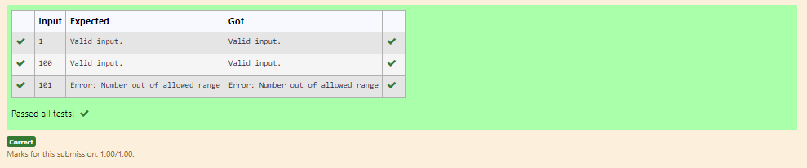

3 Write a Python program that performs division and modulo operations on two numbers provided by the user. Handle division by zero and non-numeric inputs.

Input Format:

Two lines of input, each containing a number.

Output Format:

Print the result of division and modulo operation, or an error message if an exception occurs.

**For example:**

| **Input** | **Result** |
| --- | --- |
| 10  2 | Division result: 5.0  Modulo result: 0 |
| 7  3 | Division result: 2.3333333333333335  Modulo result: 1 |
| 8  0 | Error: Cannot divide or modulo by zero. |

Program:

try:

num1 = float(input())

num2 = float(input())

division_result = num1 / num2

modulo_result = int(num1 % num2)

print("Division result: {}".format(division_result))

print("Modulo result: {}".format(modulo_result))

except ValueError:

print("Error: Non-numeric input provided.")

except ZeroDivisionError:

print("Error: Cannot divide or modulo by zero.")

except Exception as e:

print("An unexpected error occurred:", e)

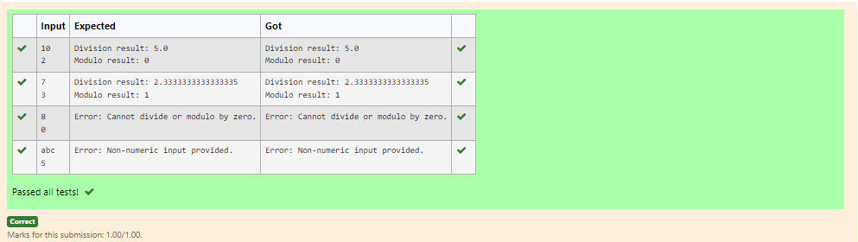

4 Problem Description:

Write a Python program that asks the user for their age and prints a message based on the age. Ensure that the program handles cases where the input is not a valid integer.

Input Format:

A single line input representing the user's age.

Output Format:

Print a message based on the age or an error if the input is invalid.

**For example:**

| **Input** | **Result** |
| --- | --- |
| 25 | You are 25 years old. |
| rec | Error: Please enter a valid age. |
| -5 | Error: Please enter a valid age. |

Program:

try:

age=(input())

age = int(age)

if age < 0:

print("Error: Please enter a valid age.")

else:

print(f"You are {age} years old.")

except EOFError:

print("Error: Please enter a valid age.")

except ValueError:

print("Error: Please enter a valid age.")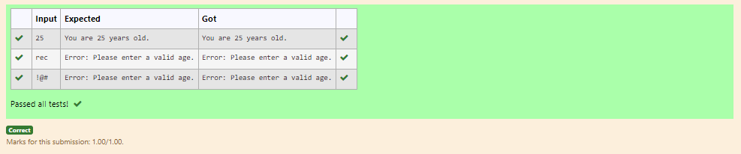

5.  Develop a Python program that safely performs division between two numbers provided by the user. Handle exceptions like division by zero and non-numeric inputs.

**Input Format:** Two lines of input, each containing a number.

**Output Format:** Print the result of the division or an error message if an exception occurs.

**For example:**

| **Input** | **Result** |
| --- | --- |
| 10  2 | 5.0 |
| 10  0 | Error: Cannot divide or modulo by zero. |
| ten  5 | Error: Non-numeric input provided. |

Program:

try:

num1 = float(input())

num2 = float(input())

result = num1 / num2

print(result)

except ValueError:

print("Error: Non-numeric input provided.")

except ZeroDivisionError:

print("Error: Cannot divide or modulo by zero.")

except Exception as e:

print("An unexpected error occurred:", e)